IM Chain was invited to participate in Russia's blockchain economic forum

On March 27, 2018, Mr. Li Chengkun, Senior VP of IM Chain, was invited to participate in the Russian Blockchain Economic Forum hosted by the Russian Blockchain Association and co-organized by the MaxPower Foundation.

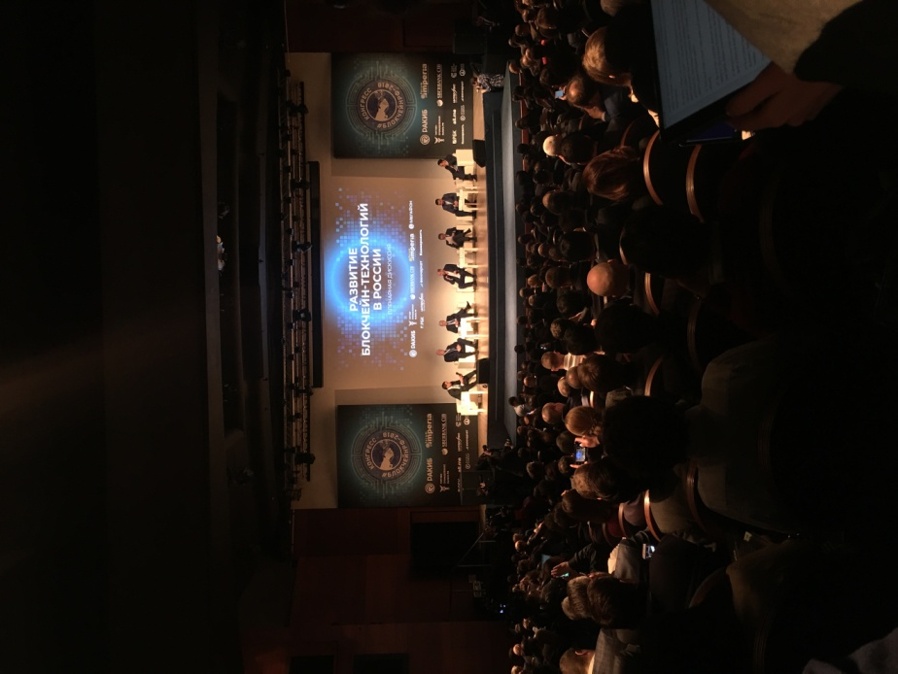

There are several high-level officials of the Russian Federation (the first vice president, the president of the Central Bank, the chairman of the State Duma Economic Policy Committee, the Federal Communications Minister, etc.) join this conference, as well as prominent financial circles, famous entrepreneurs, economists, and Block chain researchers. More than 2,000 people participated in the conference to discuss the future trend of global blockchain technology.

At local time March, 27th 10:30am, Mr. Yury PRIPACHKIN, the Chairman of the Russian Blockchain Association, held a roundtable meeting with Chinese blockchain companies. The Chinese representatives included IM Chain and other project parties, investors, technology parties. During the meeting, the Chairman of the Russian Blockchain Association stated that Russian authorities is very concerned about the importance of the development and application of blockchain technology. They are developing their own Blockchain industry, and at same time actively seeking cooperation with outstanding foreign companies, and planing to establish the Asia-Europe blockchain association, cooperate with Asian and European countries and develop blockchain technology.

According to a recent report from Russia’s TASS, the Russian blockchain supervision outline will be released in the coming few months. During a meeting with students of the Russian University of Economics at Plekhanov, Russian Deputy Prime Minister Arkady Dvorkovich stated: "Russia needs to create a blockchain regulatory framework, not necessarily too detailed, but We hope that we will not limit the implementation of blockchain projects. We will do this as soon as possible, and we have begun this work. It is expected that blockchain legislation will be resolved in the coming months." The meeting was confirmed again on the same day.

IM Chain has been deeply creating smart manufacturing technologies. The successful creation of the Intelligent Manufacturing Chain Platform, is building a new production method deeply integrating blockchain technology and intelligent manufacturing technologies. It utilizes blockchain as the underlying technology with information-oriented technology and data driven demand to create the C2C, B2C, and B2B e-commerce cloud service ecosystem platform of the manufacturing terminal. It is a global, open and integrated system include security, convenience, and intelligence properties, as well as the optimization of allocating resources and energy, and maximized product quality.

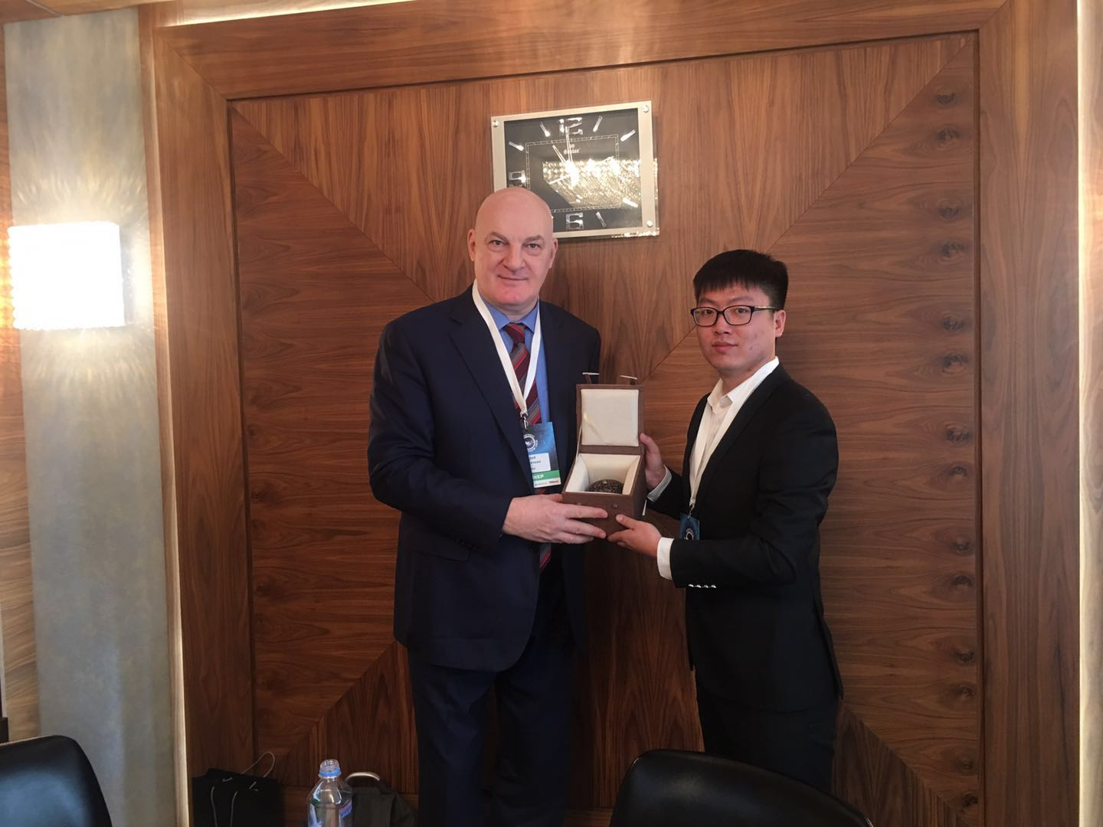

During the roundtable session, IM Chain presented the cooperated partner KANGSHUO group's 3D printed cultural and creative product Xuande “Lion Furnace” to Yury PRIPACHKIN, Chairman of the Russian Blockchain Association with a high evaluation. The product combined traditional Chinese culture with the latest manufacturing technology.

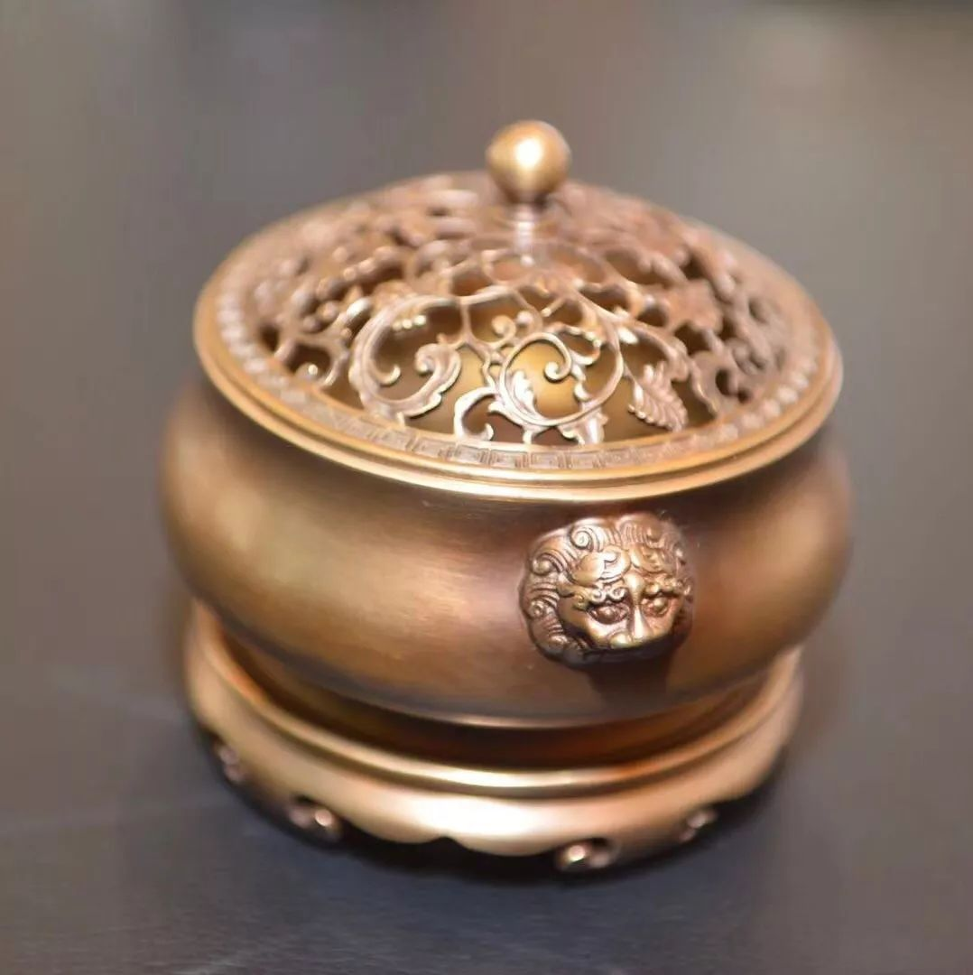

This lion ear furnace has dignified atmosphere, giving people a steady dignified momentum, its mouth and extravagant, its neck slow, rounded to the end. Height is strong, belly sagging, lap high and outside. The lions on both sides of the lion are powerful, they are large in size, have teeth in their mouths, and curly mane hair. The Xuande emperor made this furnace and gave it to the Ministry of Military Affairs. With its implication, the lion is the king of the all beasts, taking its authority to lead the Six Forces. The trend of the furnace was wonderful at the Lionhead, and its furnace was collected. When the shape of the lion's head was carefully investigated, the work was performed and the savior of God was taken to be good. The lion's head in the Ming dynasty, and Yan Qiwei's valiant slayer, covered the battle. The lion head furnace, Xuande for the Ministry of weapons, Kong Wuwei fierce, Shen Xiong domineering, taking its mighty meaning. The "Daiming Xuande Furnace Overview" describes the originals, inherits them in an orderly manner, and collects beautiful devices.